4 Capstone Project

* In this project, we need you to build an application that takes input as Longitude, Latitude and the data selected which is gapminder or iris in the input page and in the output page it should display the given graphs and the entered value.
* The page should be multipage app and should use the concept of data sharing using dcc.store.
* The first page is this app is about page which consists of information , second page consist of input values and third page should display output values.

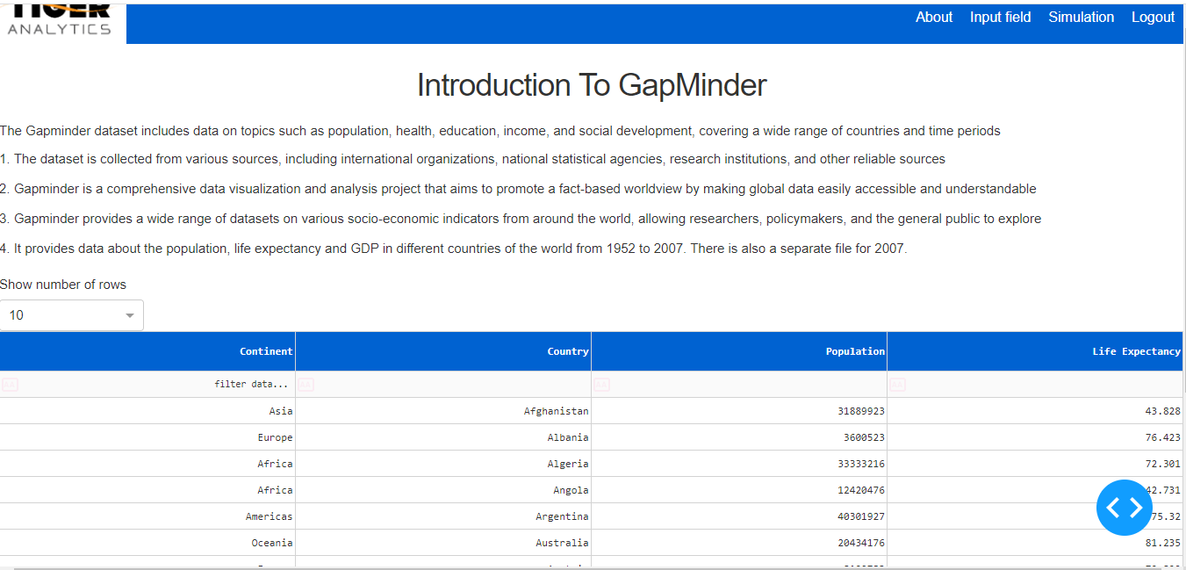

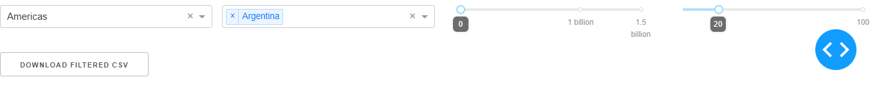

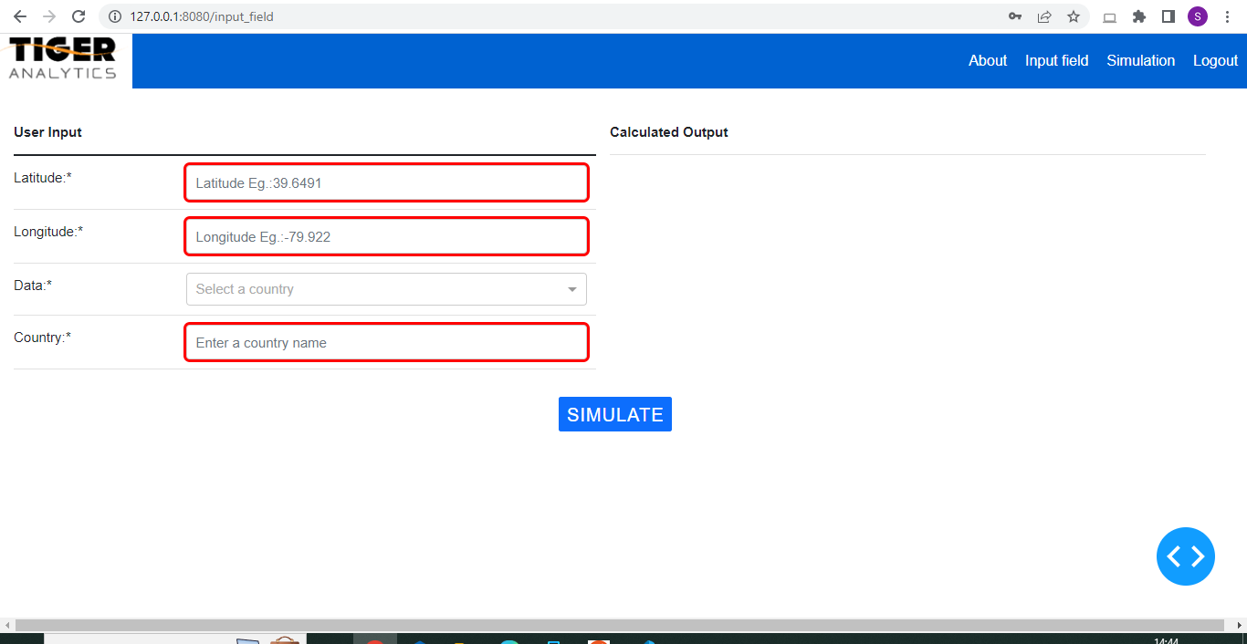

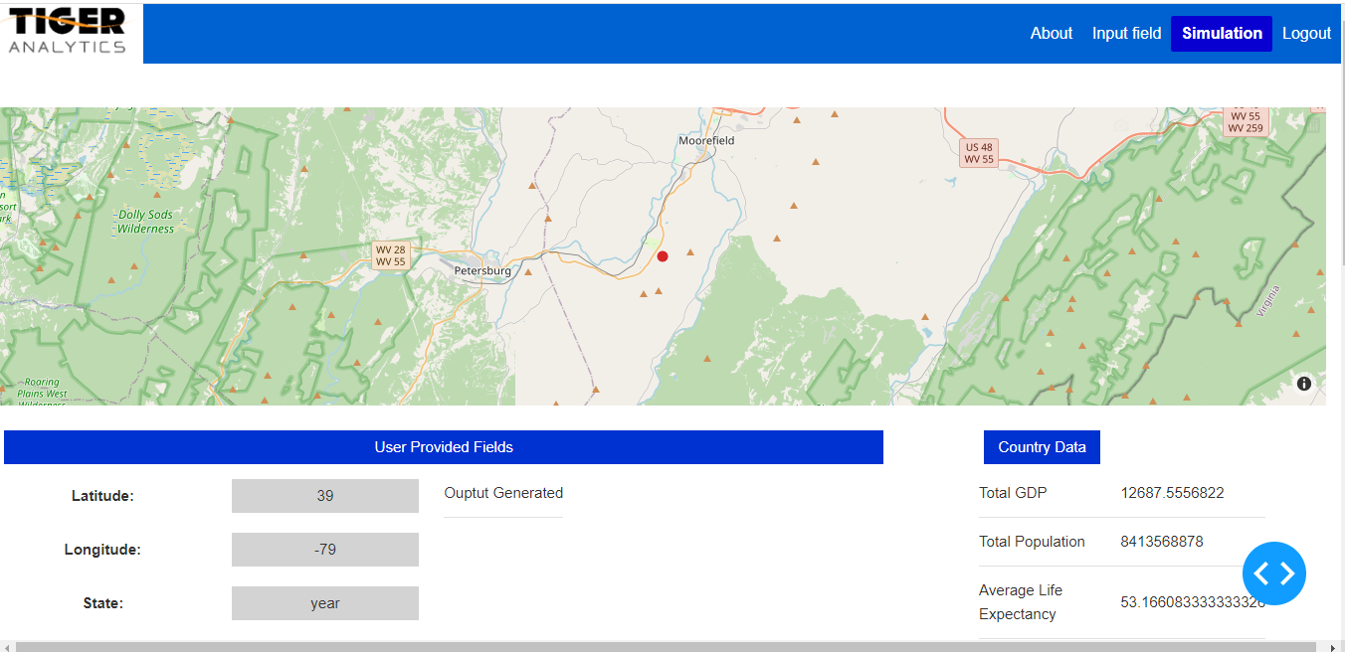

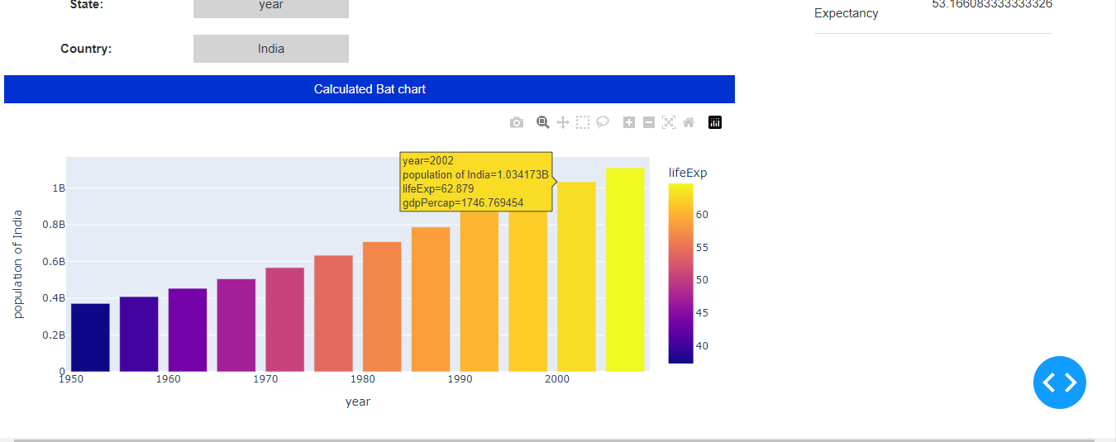

* Use Flask-login on top of a Dash application for users authentication.